**Command Line Argument, Variable Argument Handling Assignment**

1. Write a program to

a. read a name(of max length 40 characters), ip address (as char * string in dotted notation) and port number (unsigned short) of the cloud server as command line arguments.

Ans:

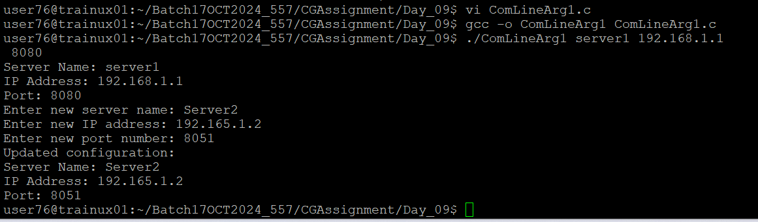

b. Validate if the required number of arguments have been received before proceeding. Else report error and return.

Ans: Validation

* Ensure the IP address is in the correct format.
* Ensure the port number is within the valid range (1-65535).

c. Validate every argument received for valid range of values.

[Refer ip address range, port range to do validations]

Ans: Data Structure

* The struct server is used to store the server configuration.

d. Store the values in a data structure and display using a function passing data structure

void display(struct server *servercfg);

Ans: Display Function

* The display function prints the server configuration.

e. Implement a function update() to prompt user, to modify all the server attributes and to display the updated configuration.

// to read, update configuration and return status as SUCCESS/FAILURE Int update(struct server *servercfg);

Ans: Update Function

* The update function prompts the user to modify the server attributes.

f. Specify atleast 6 test cases (positive and negative ) to test command line inputs and update operations

Ans: Test Cases

1. Valid inputs: ./program server1 192.168.1.1 8080
2. Invalid IP: ./program server1 999.999.999.999 8080
3. Invalid port: ./program server1 192.168.1.1 70000
4. Missing arguments: ./program server1 192.168.1.1
5. Valid update: Modify attributes to valid values during update.
6. Invalid update: Modify attributes to invalid values during update.

g. Check for memory leaks and fix them.

Ans: Memory Leaks

* Ensure no dynamic memory allocation is used, or if used, it is properly freed.

2. Implement a log() with signature as below to display all the input arguments as per their type. [Hint: In log() , use vfprintf() to display the received inputs]

void log(const char *format, …);

For e.g.

int main()

{

int count = 10;

char prefix = ‘h’;

char label[] = “India”;

…

log(“count:%d, prefix:%c, label:%s”, count, prefix, label);

…

}

Expected Output:

count:10,prefix:h,label:India

Ans:

3. Refer the code “find_max.c”. Add a function below to accept variable number of strings and to return the string with maximum length to the caller. In case of strings with same length, return the first string in the input sequence

max_len_string(<variable number of arguments>)

Eg. Code below shoud output “hello”

char *ptr = max_len_string(“hi”, “hello”, “How”, “ Are”, “END”);

printf(“%s”, ptr);

Ans:

